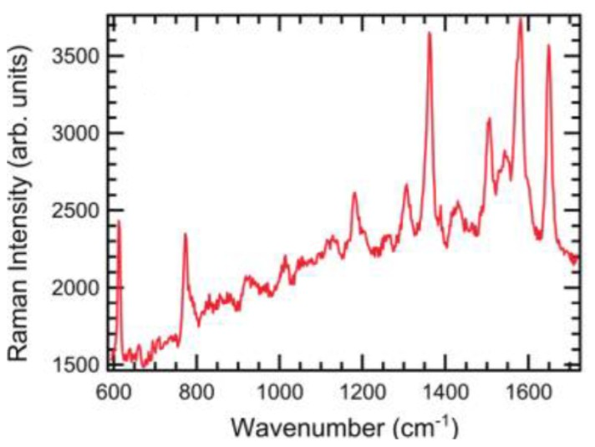

Figure 1: <https://doi.org/10.1021/nl204446h>

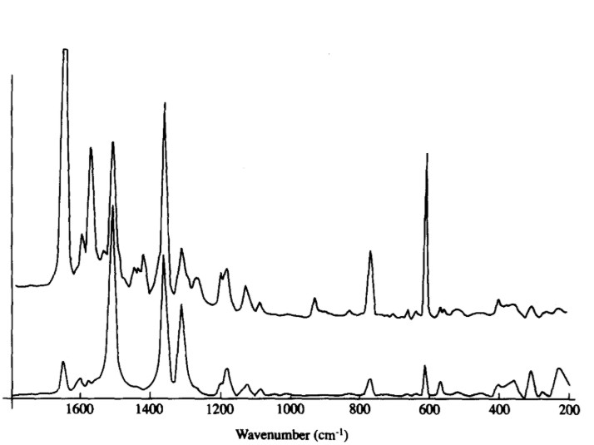

Figure 2: <https://doi.org/10.1016/0584-8539(91)80237-D>

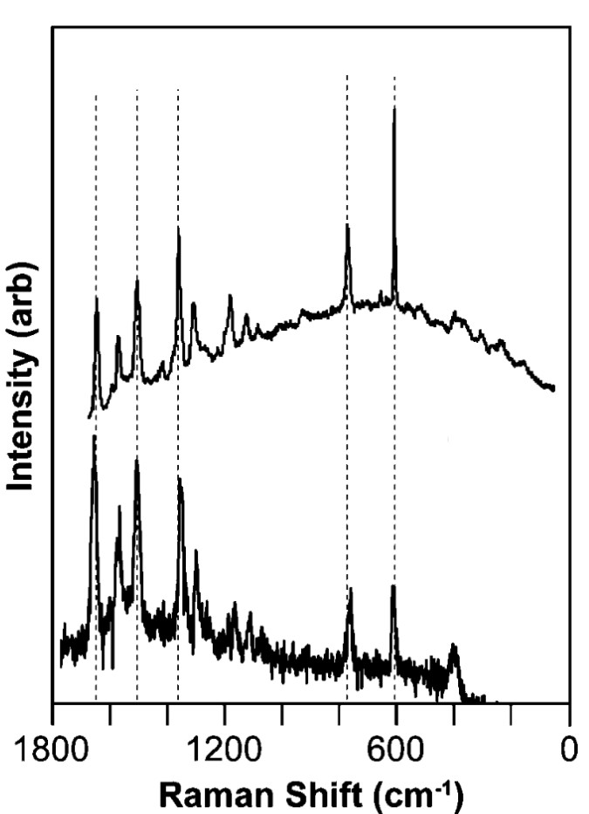

Figure 3: <https://doi.org/10.1021/ja8080154>

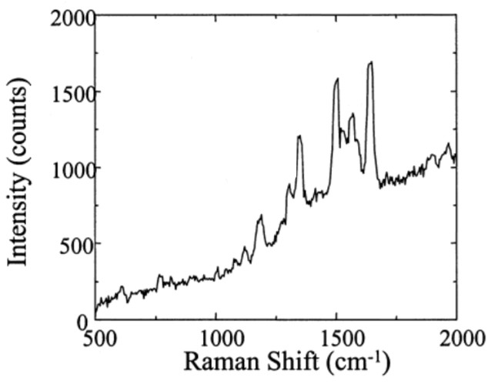

Figure 4: <https://doi.org/10.1021/jp0025476>

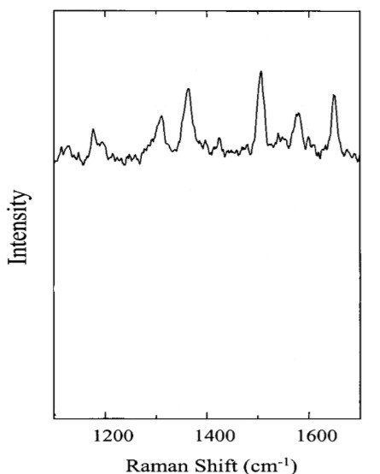

Figure 5: <https://doi.org/10.1021/jp0025476>

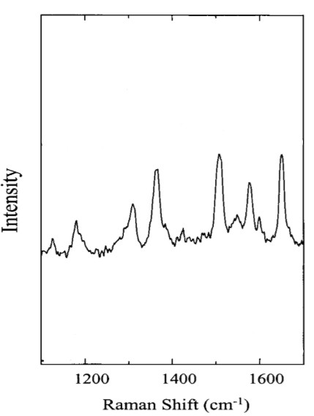

Figure 6: <https://doi.org/10.1021/jp0025476>

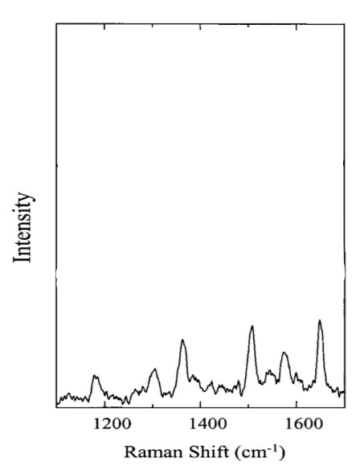

Figure 7: <https://doi.org/10.1021/jp0025476>

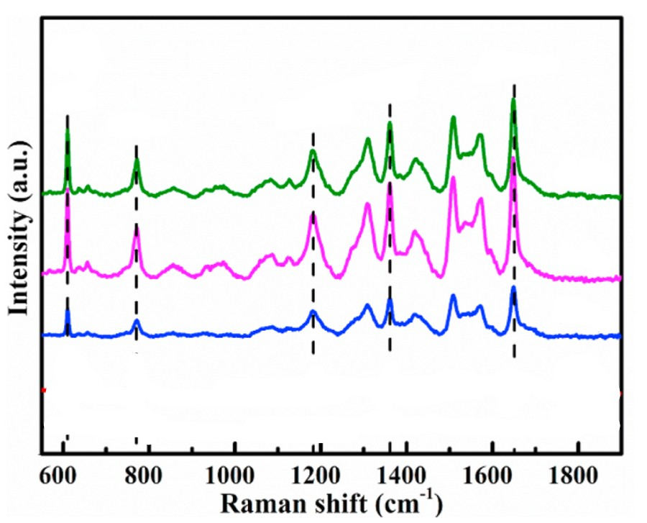

Figure 8: https://doi.org/10.1016/j.vacuum.2021.110096

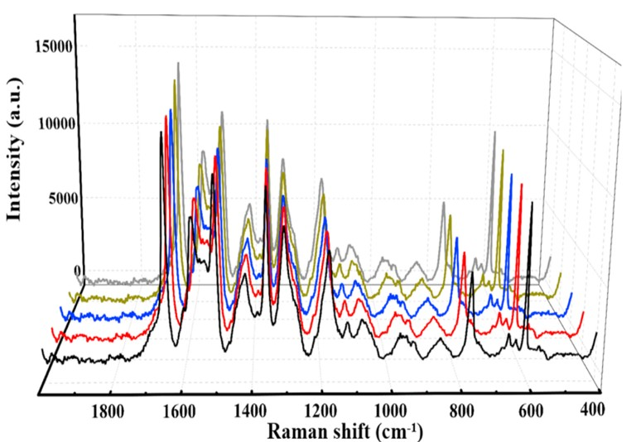

Figure 9: https://doi.org/10.1016/j.vacuum.2021.110096

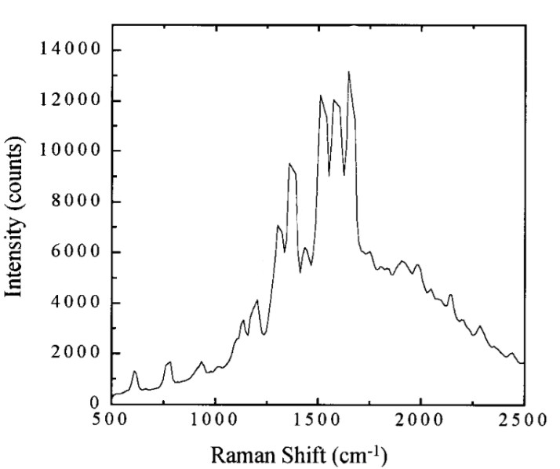

Figure 10: <https://doi.org/10.1021/ja992128q>

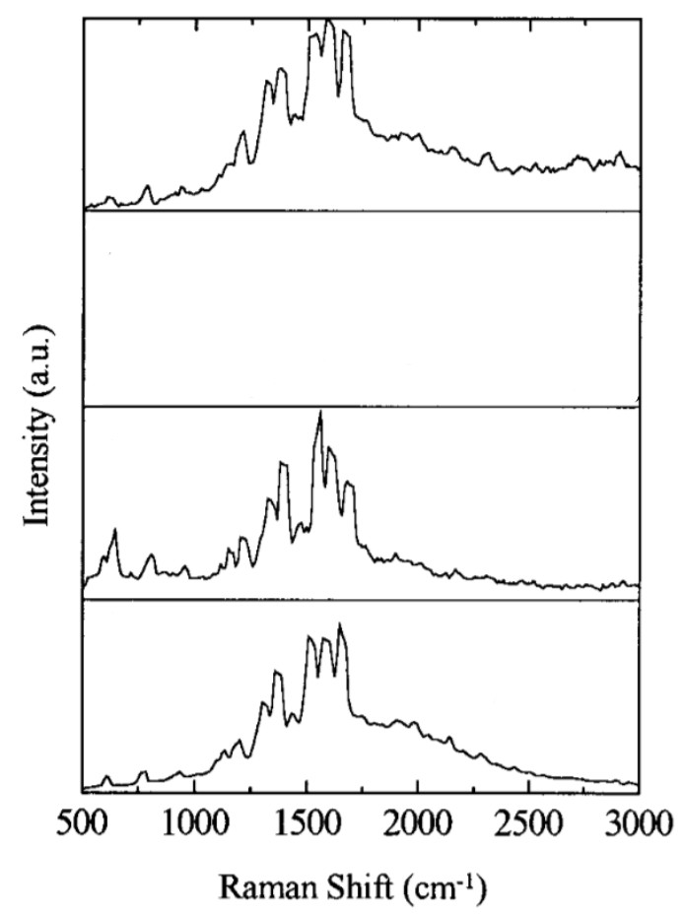

Figure 11: <https://doi.org/10.1021/ja992128q>

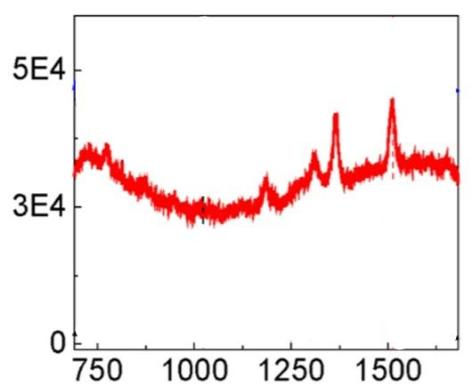

Figure 12: <https://doi.org/10.1021/jp4105932>

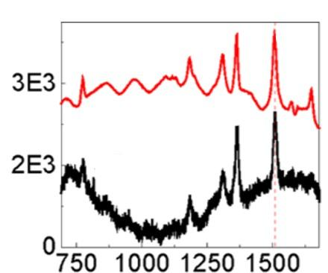

Figure 13: <https://doi.org/10.1021/jp4105932>

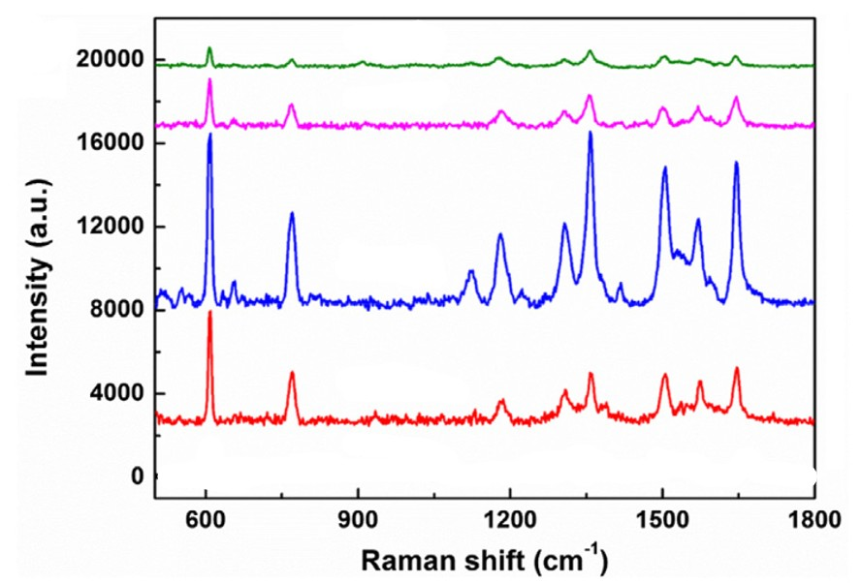

Figure 14: <https://doi.org/10.1016/j.apsusc.2018.06.094>

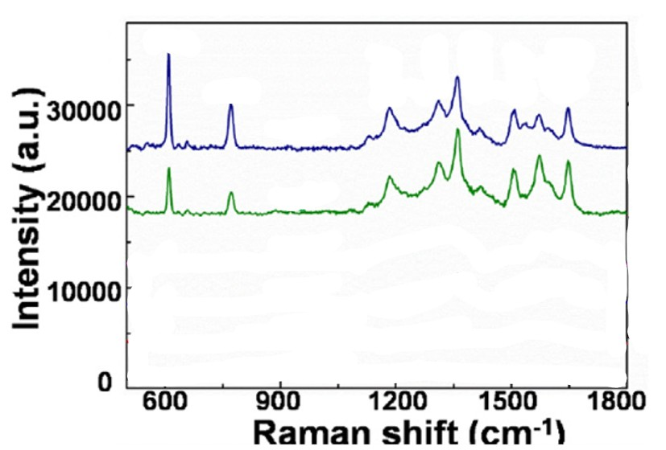

Figure 15: https://doi.org/10.1016/j.apsusc.2018.06.094

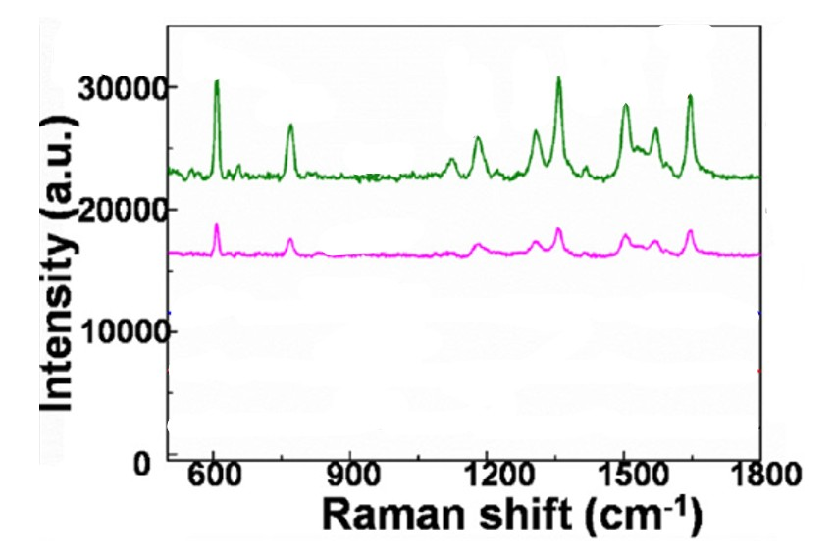

Figure 16: https://doi.org/10.1016/j.apsusc.2018.06.094

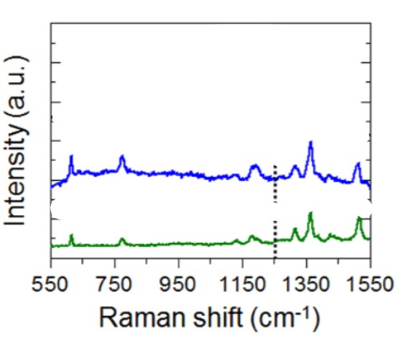

Figure 17: <https://doi.org/10.1021/acs.chemmater.5b03714>

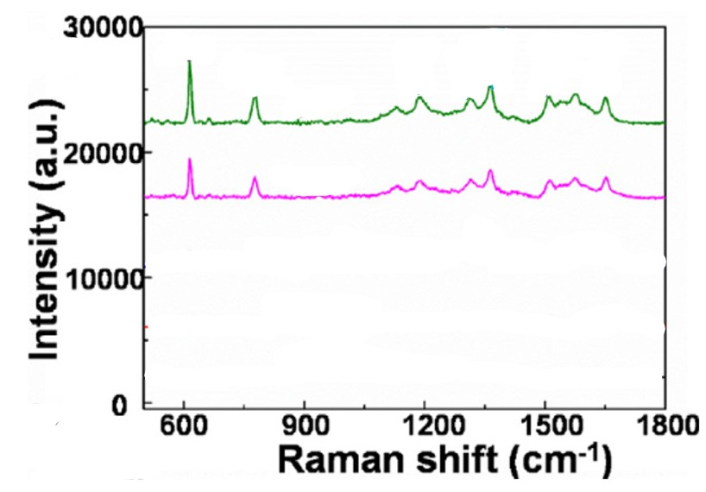

Figure 18: https://doi.org/10.1016/j.apsusc.2018.06.094

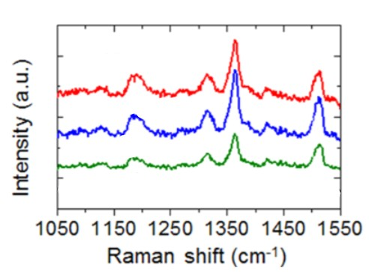

Figure 19: <https://doi.org/10.1021/acs.chemmater.5b03714>

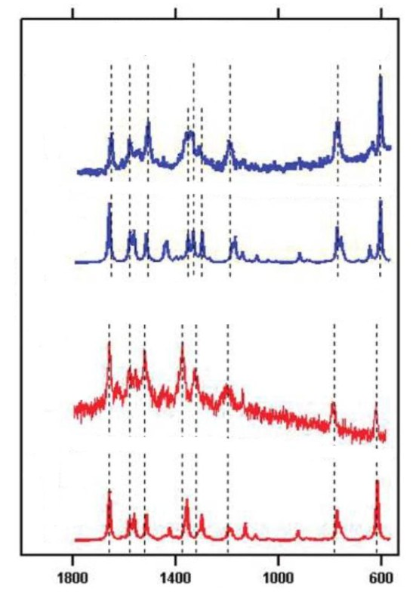

Figure 20: <https://doi.org/10.1021/jp209982h>

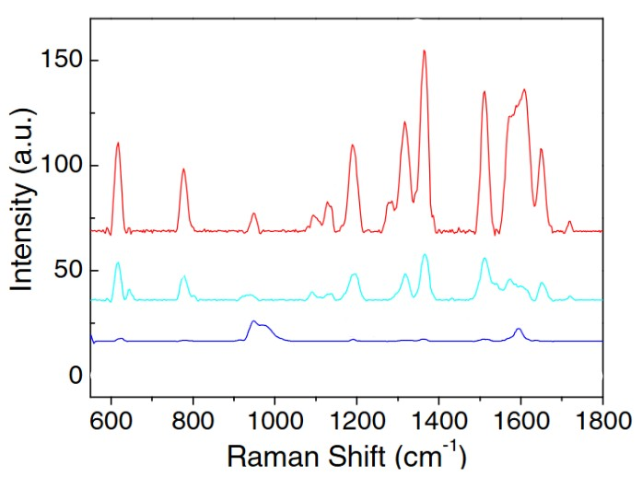

Figure 21: <https://doi.org/10.1016/j.carbon.2015.01.028>

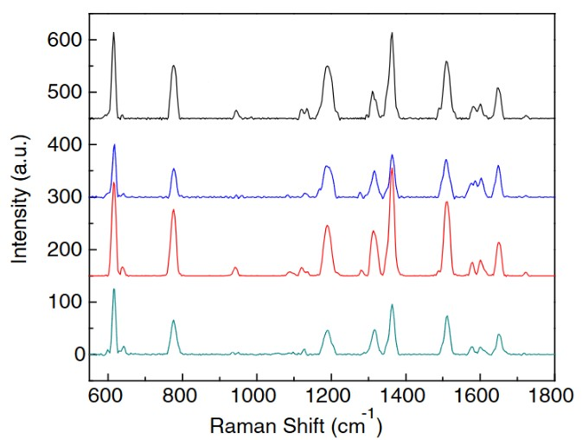

Figure 22: <https://doi.org/10.1016/j.carbon.2015.01.028>

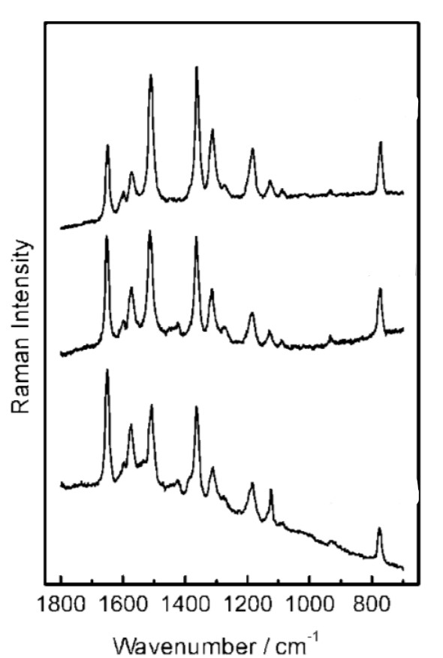

Figure 23: <https://doi.org/10.1002/jrs.1352>

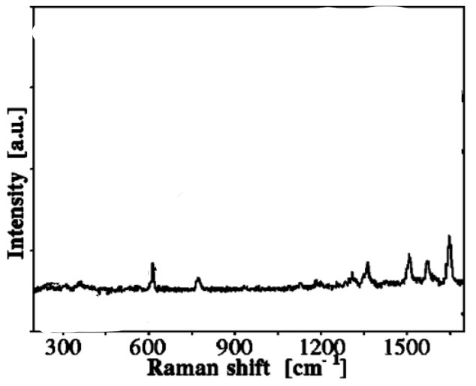

Figure 24: <https://doi.org/10.1063/1.1344225>

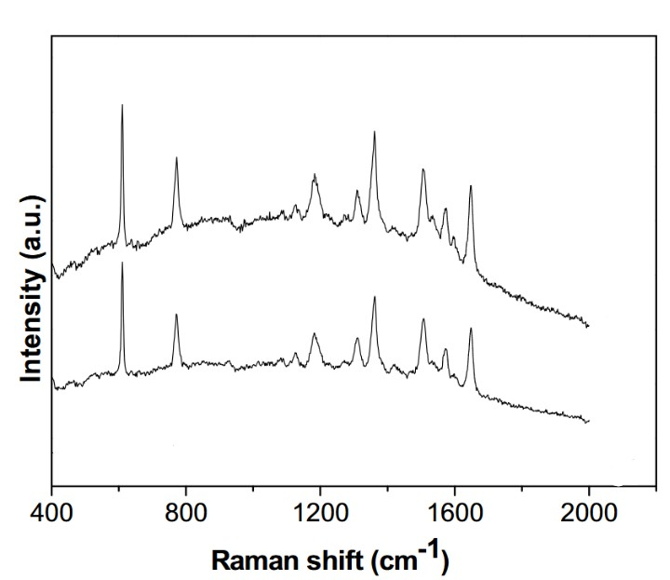

Figure 25: <https://doi.org/10.1016/j.colsurfa.2016.07.020>

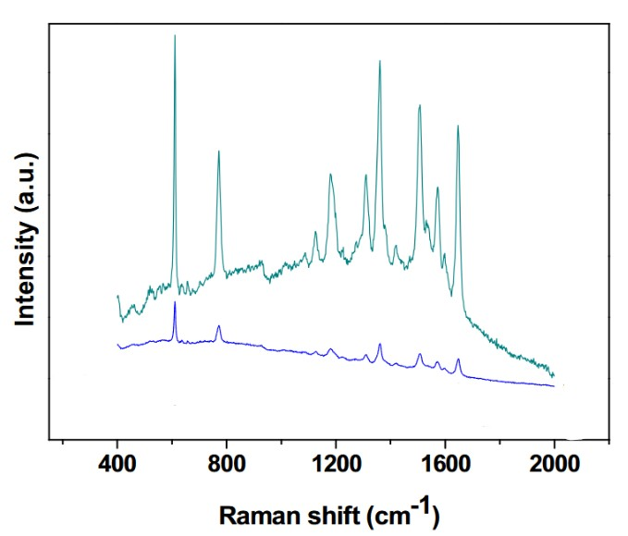

Figure 26: <https://doi.org/10.1016/j.colsurfa.2016.07.020>

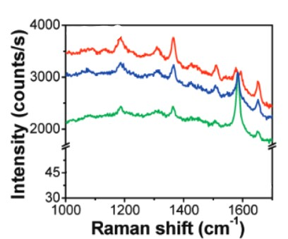

Figure 27: <https://doi.org/10.1021/ja9037593>

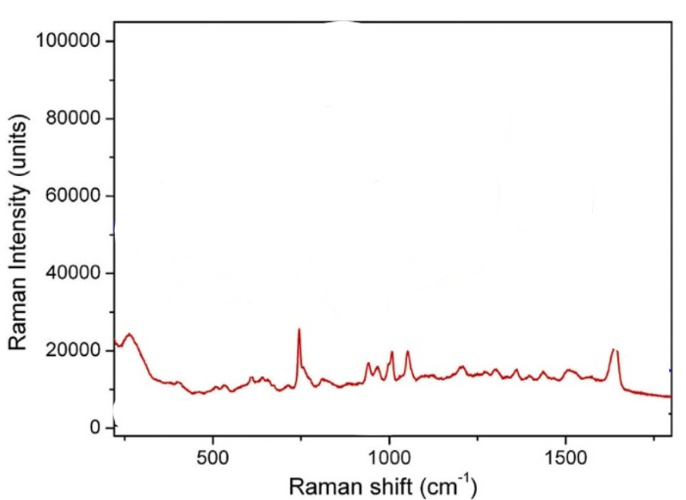

Figure 28: <https://doi.org/10.1016/j.apsusc.2015.04.152>

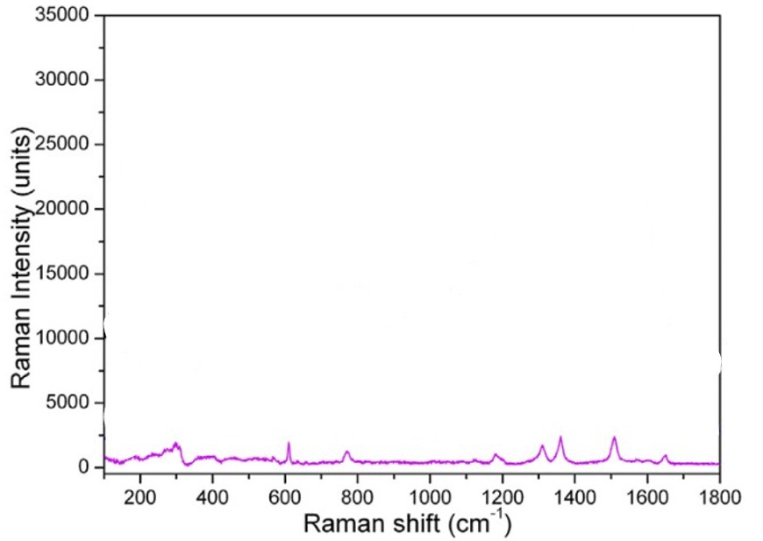

Figure 29: <https://doi.org/10.1016/j.apsusc.2015.04.152>

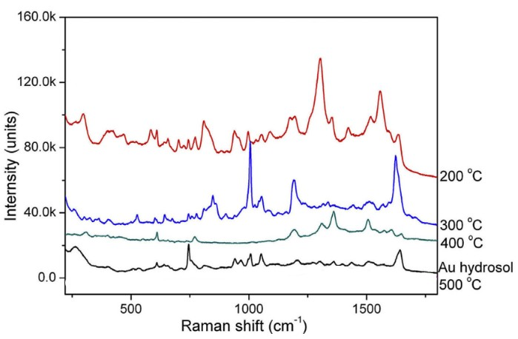

Figure 30: <https://doi.org/10.1016/j.apsusc.2015.04.152>

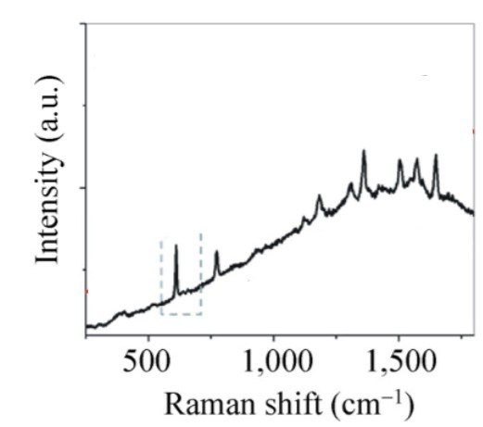

Figure 31: <https://doi.org/10.1007/s12274-014-0490-3>

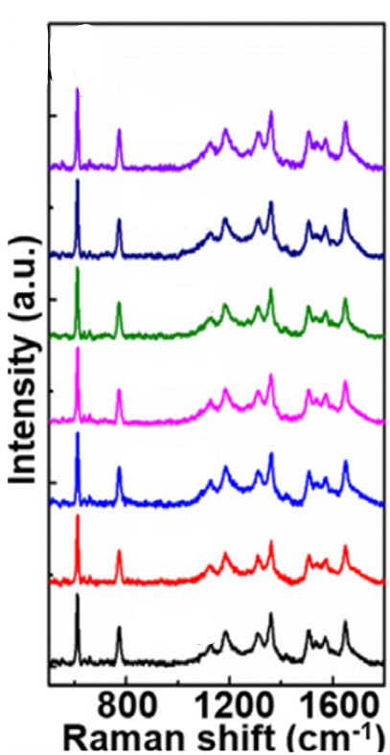

Figure 32: <https://doi.org/10.1016/j.apsusc.2018.06.094>

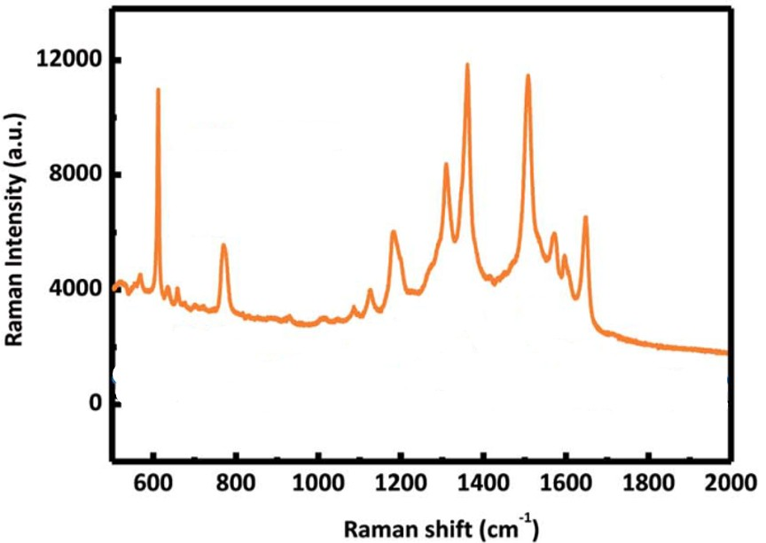

Figure 33: 10.1039/c8ra07778a

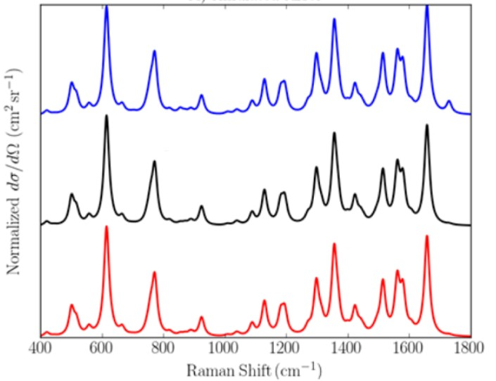

Figure 34: <https://doi.org/10.1021/acs.jpclett.7b00498>

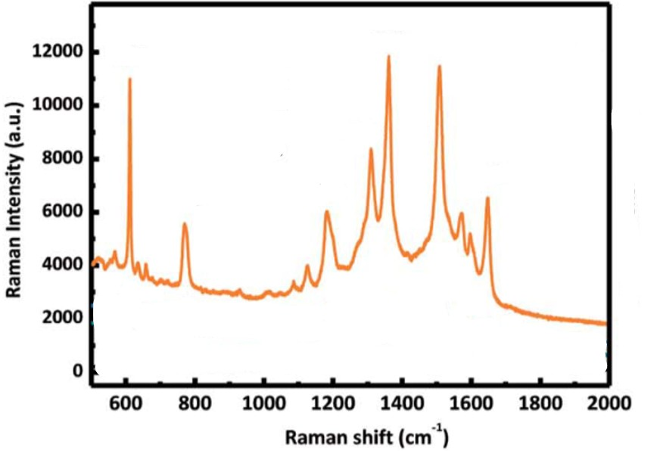

Figure 35: 10.1039/c8ra07778a

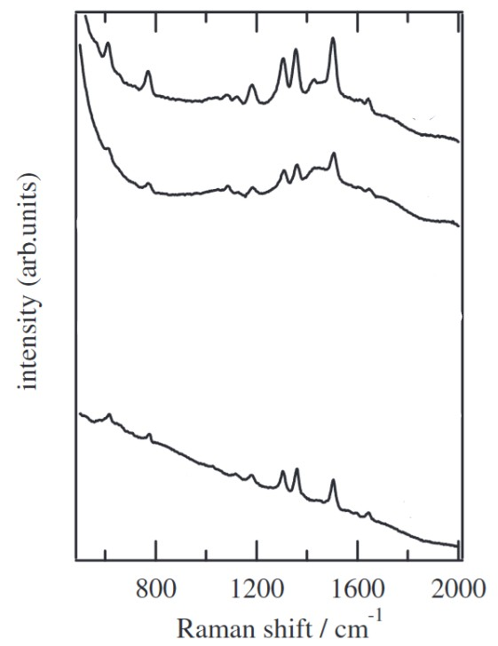

Figure 36: 10.1143/JJAP.43.L554

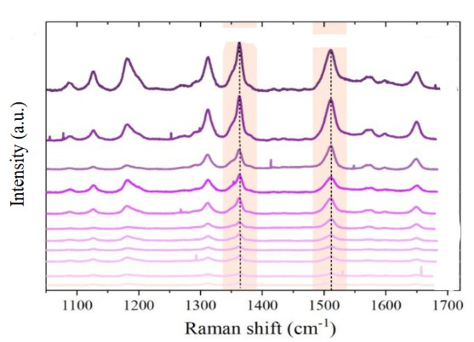

Figure 37: <https://doi.org/10.1021/acsanm.0c01530>

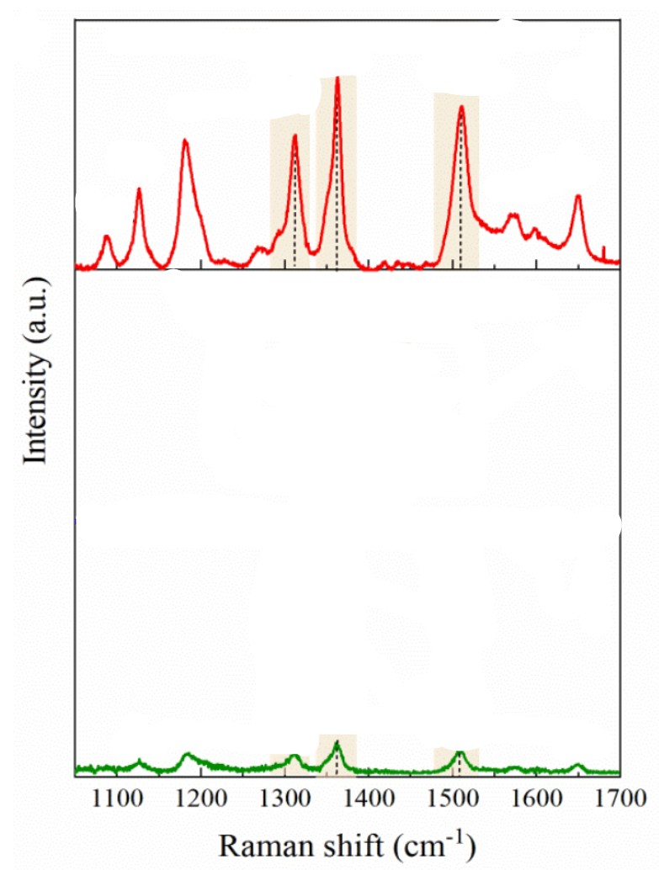

Figure 38: <https://doi.org/10.1021/acsanm.0c01530>

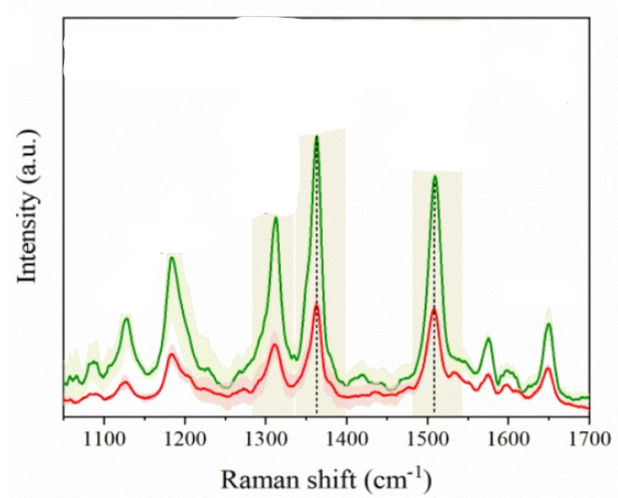

Figure 39: <https://doi.org/10.1021/acsanm.0c01530>

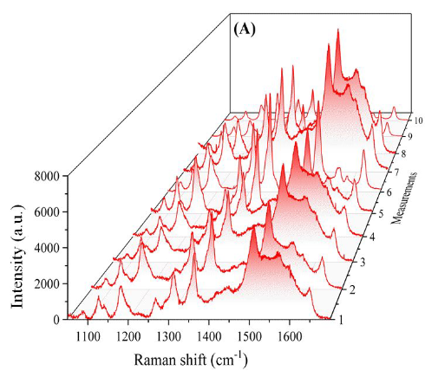

Figure 40: <https://doi.org/10.1021/acsanm.0c01530>

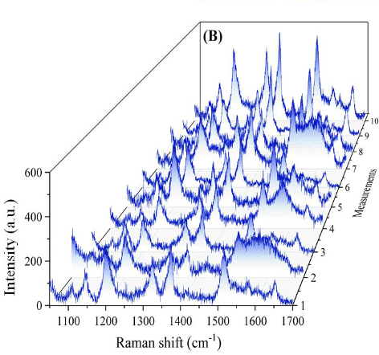

Figure 41 : <https://doi.org/10.1021/acsanm.0c01530>

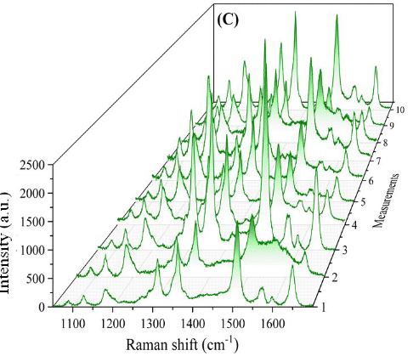

Figure 42: <https://doi.org/10.1021/acsanm.0c01530>

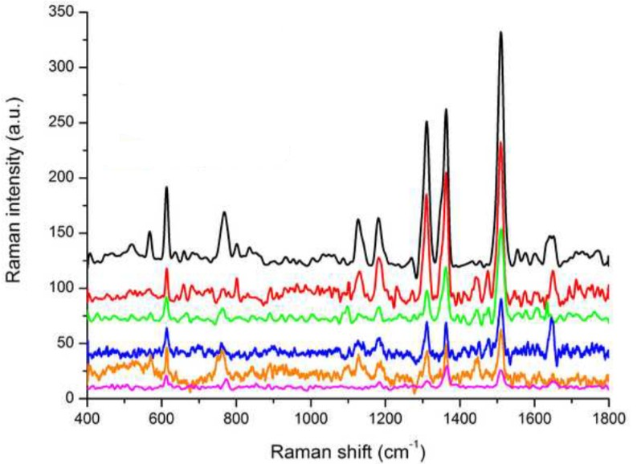

Figure 43: <https://doi.org/10.1016/j.apsusc.2014.10.095>

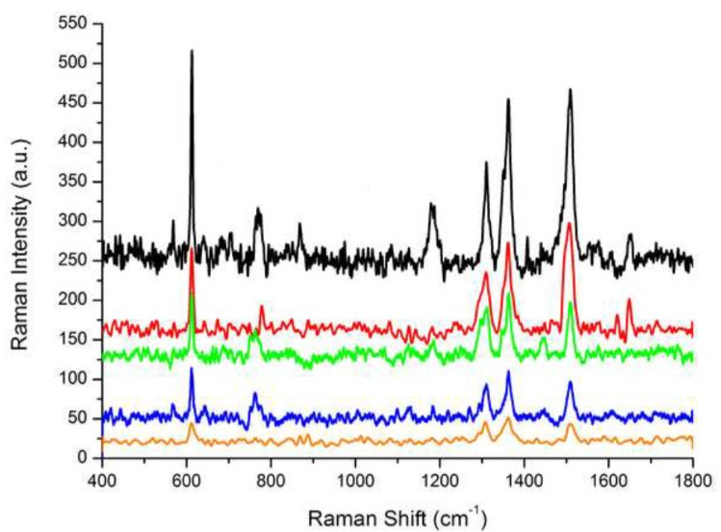

Figure 44: <https://doi.org/10.1016/j.apsusc.2014.10.095>

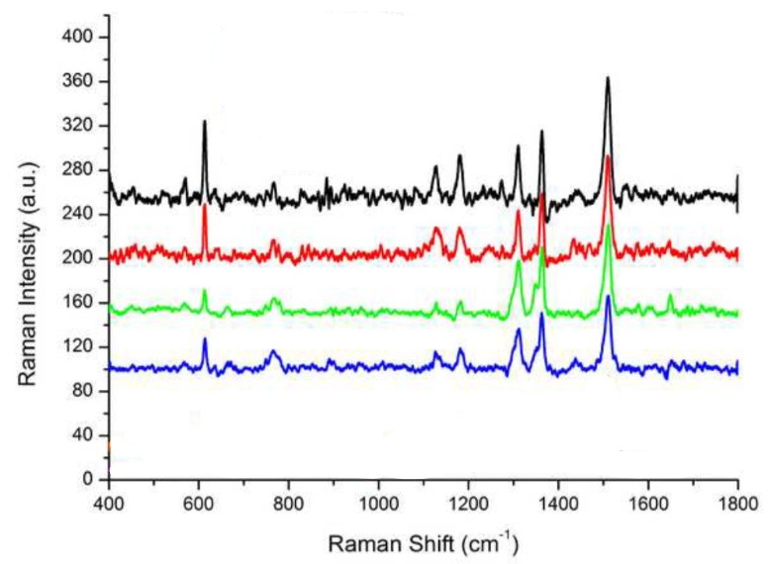

Figure 45: <https://doi.org/10.1016/j.apsusc.2014.10.095>

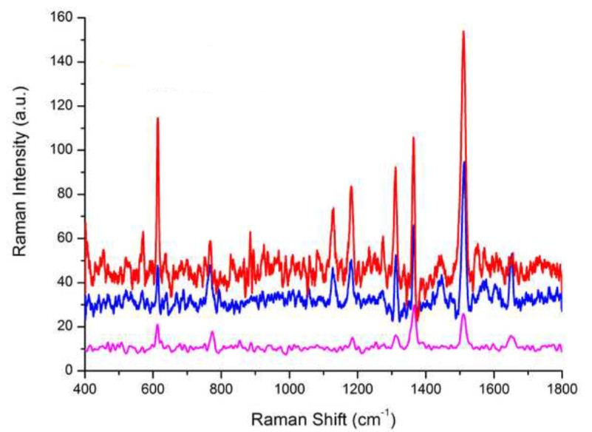

Figure 46: <https://doi.org/10.1016/j.apsusc.2014.10.095>

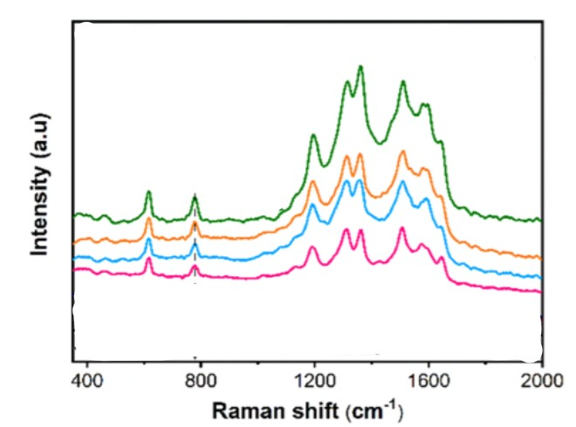

Figure 47: <https://doi.org/10.1021/acsami.9b16773>

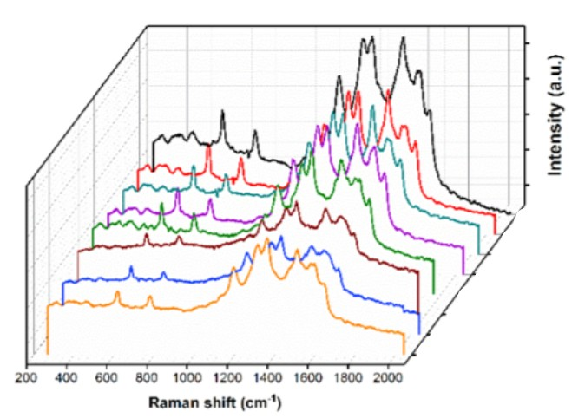

Figure 48: <https://doi.org/10.1021/acsami.9b16773>

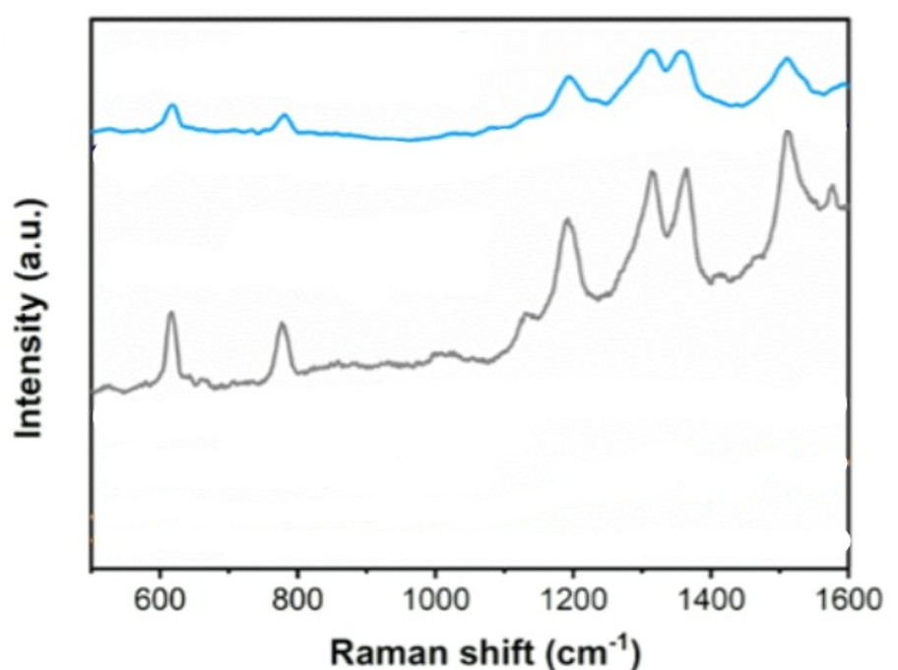

Figure 49: <https://doi.org/10.1021/acsami.9b16773>

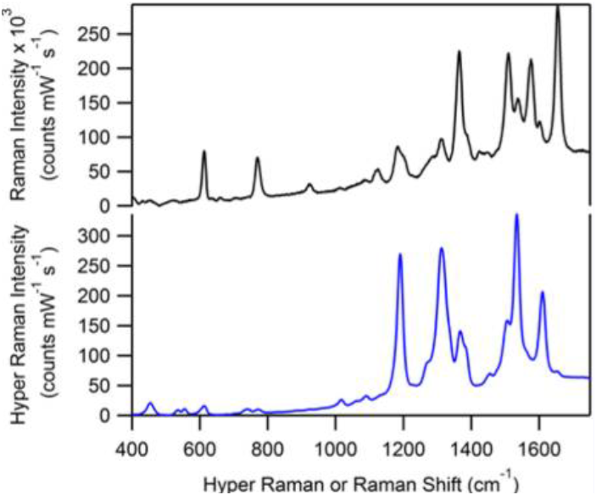

Figure 50: <https://doi.org/10.1021/jp3094098>

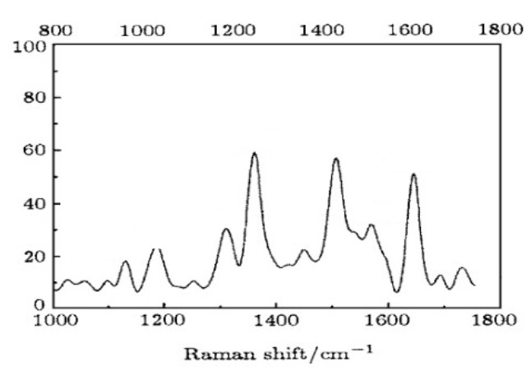

Figure 51: 10.1088/1009-1963/15/1/020

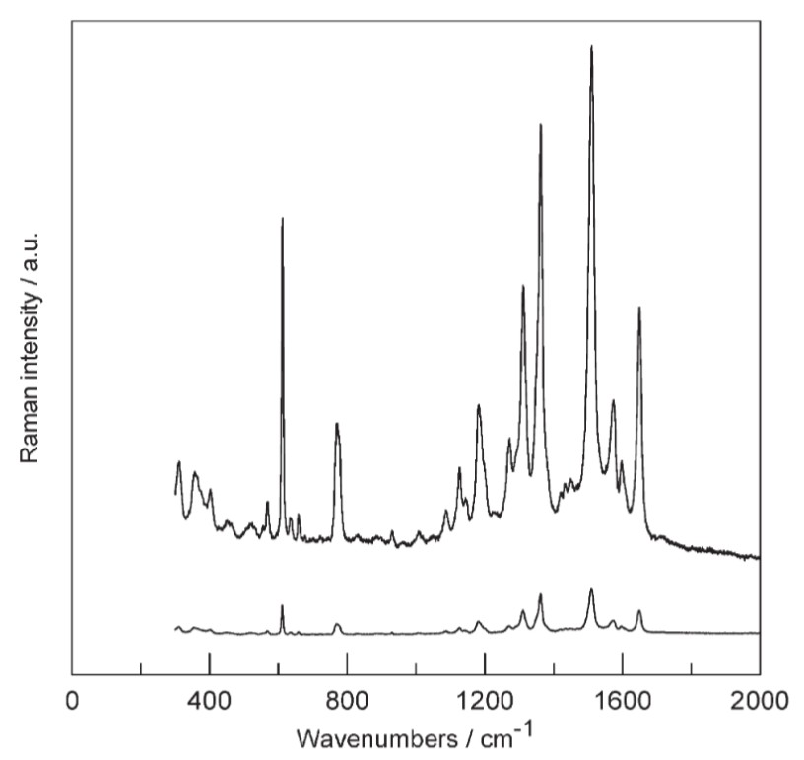

Figure 52: [**https://doi.org/10.1039/B609417A**](https://doi.org/10.1039/B609417A)

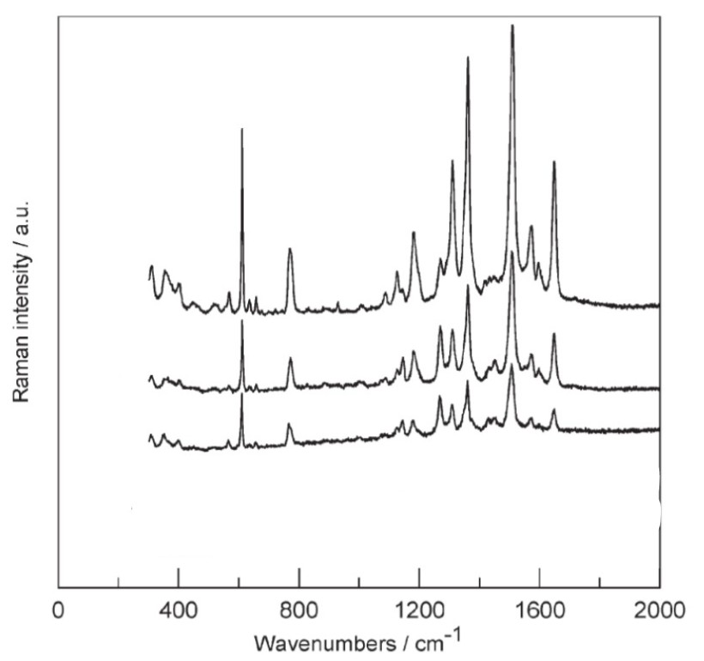

Figure 53: [**https://doi.org/10.1039/B609417A**](https://doi.org/10.1039/B609417A)

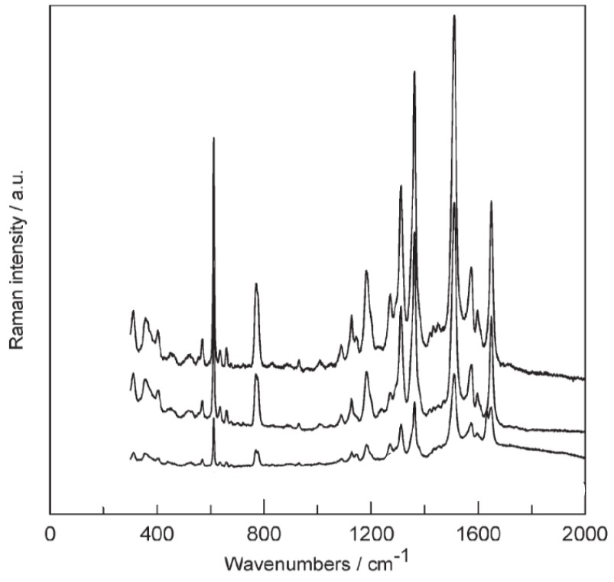

Figure 54: [**https://doi.org/10.1039/B609417A**](https://doi.org/10.1039/B609417A)

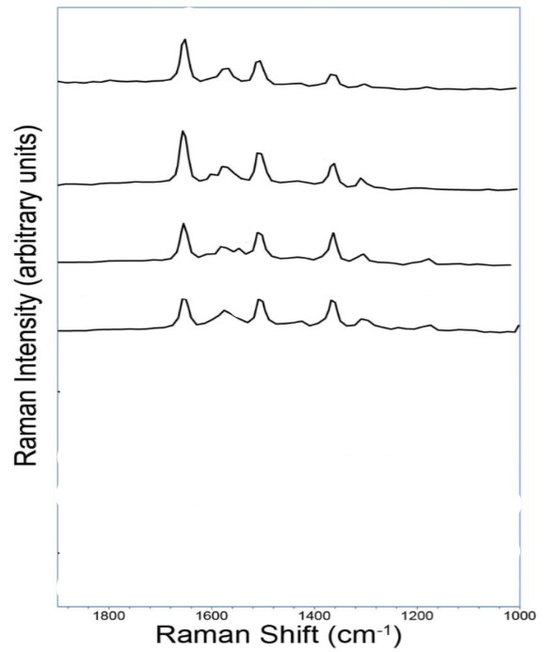

Figure 55: <https://doi.org/10.1021/acs.jpcc.7b09441>

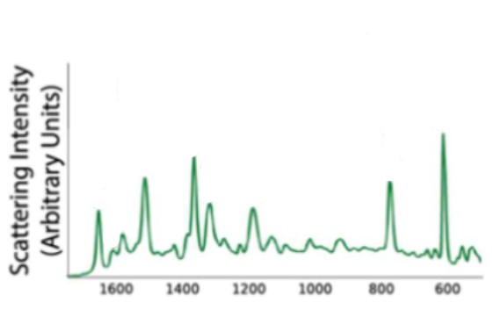

Figure 56: <https://doi.org/10.1021/acs.jpcc.7b09441>

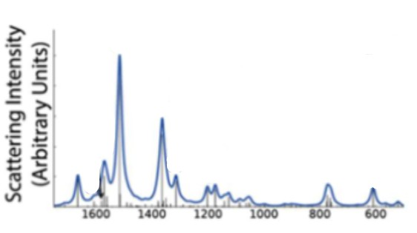

Figure 57: <https://doi.org/10.1021/acs.jpcc.7b09441>

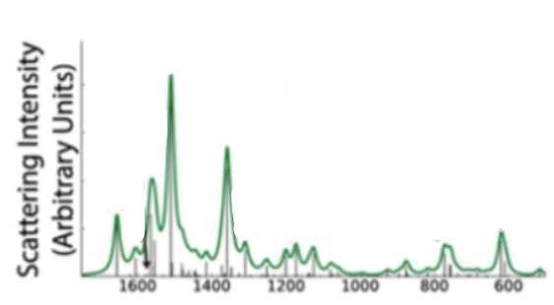

Figure 58: <https://doi.org/10.1021/acs.jpcc.7b09441>

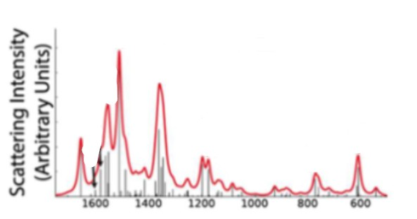

Figure 59: <https://doi.org/10.1021/acs.jpcc.7b09441>

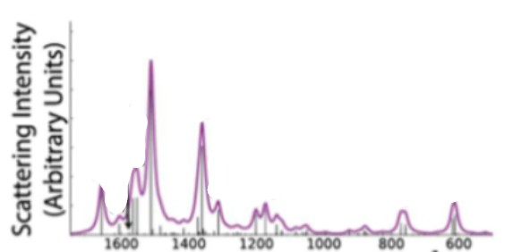

Figure 60: <https://doi.org/10.1021/acs.jpcc.7b09441>

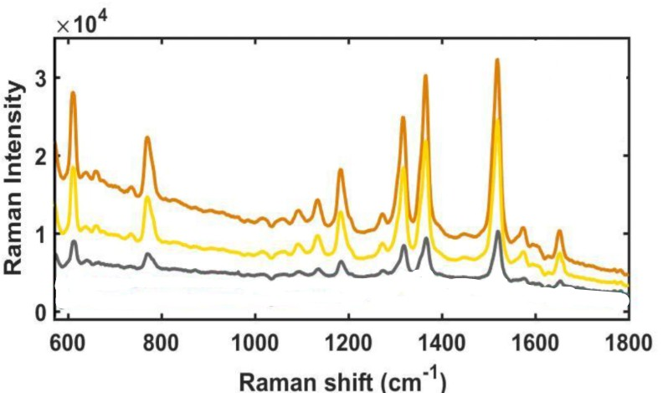

Figure 61: <https://doi.org/10.1016/j.microc.2018.04.004>

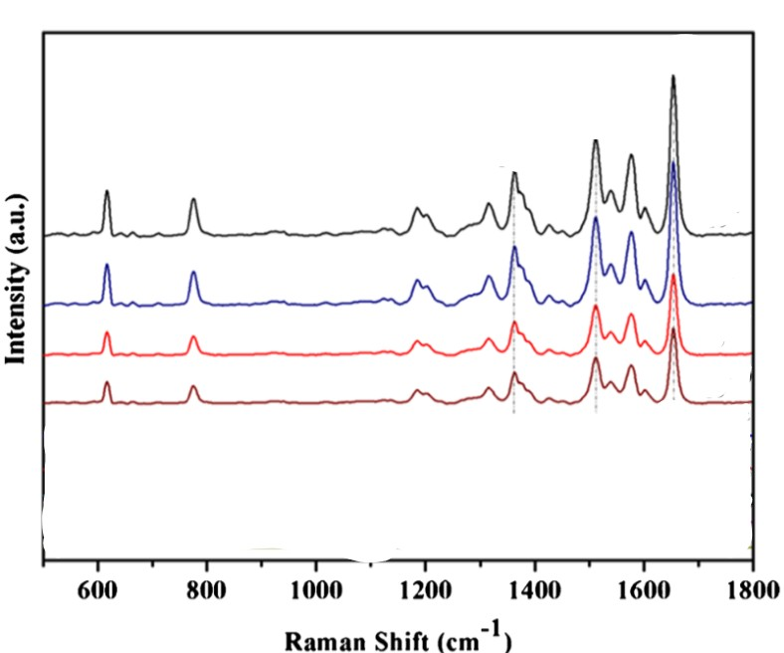

Figure 62: <https://doi.org/10.1007/s00216-017-0410-y>

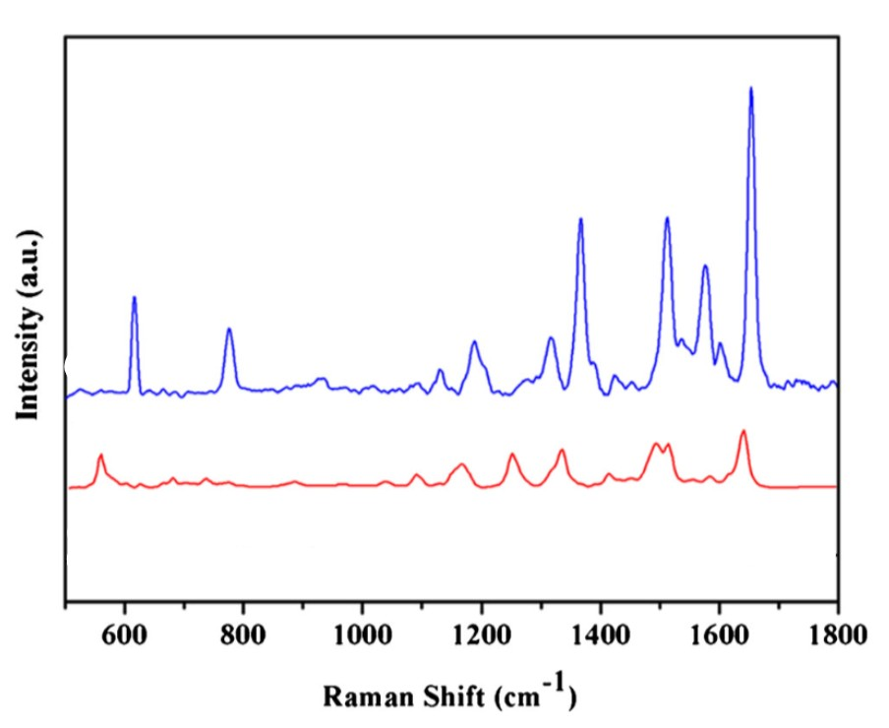

Figure 63: <https://doi.org/10.1007/s00216-017-0410-y>

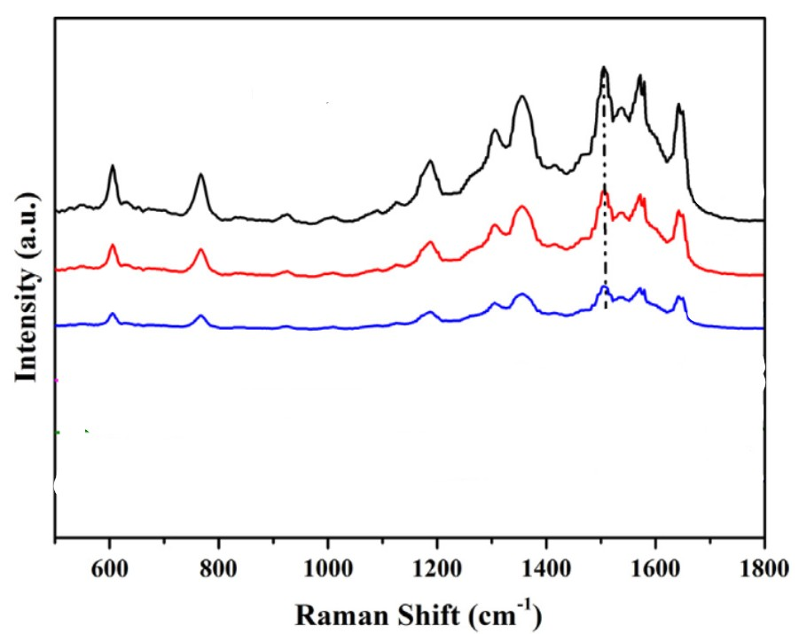

Figure 64: <https://doi.org/10.1016/j.jcis.2017.04.010>

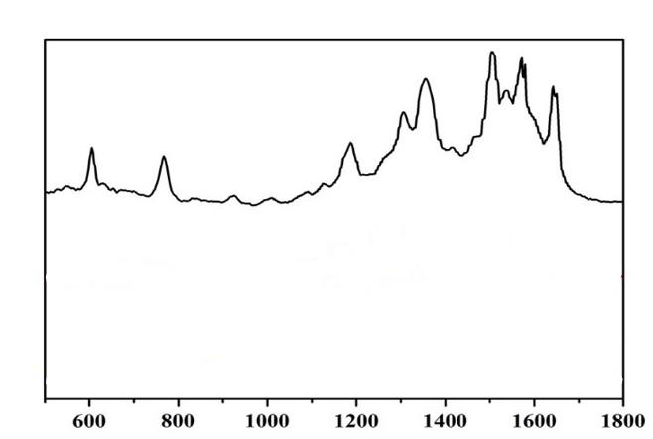

Figure 65: <https://doi.org/10.1016/j.jcis.2017.04.010>

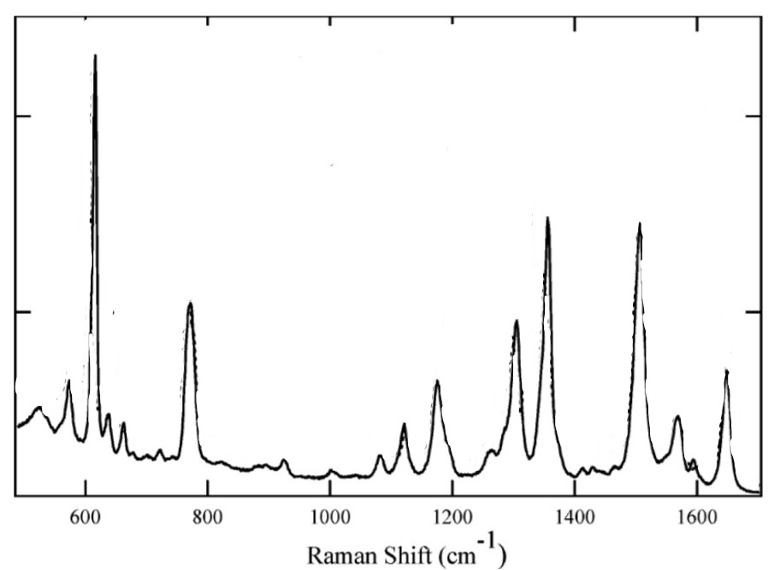

Figure 66: <https://doi.org/10.1021/ac050338h>

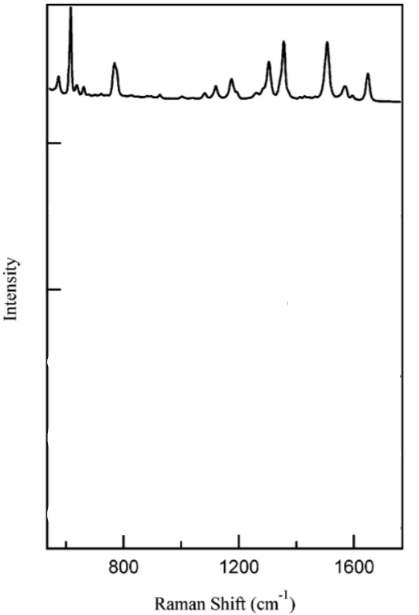

Figure 67: <https://doi.org/10.1021/ac050338h>

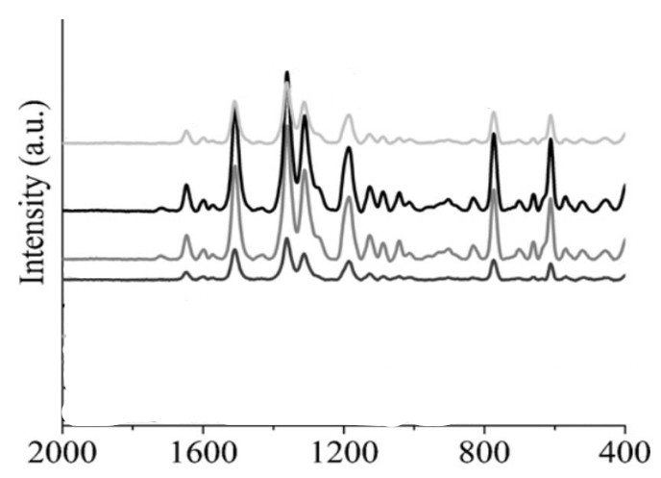

Figure 68: <https://doi.org/10.1016/j.vibspec.2011.09.006>

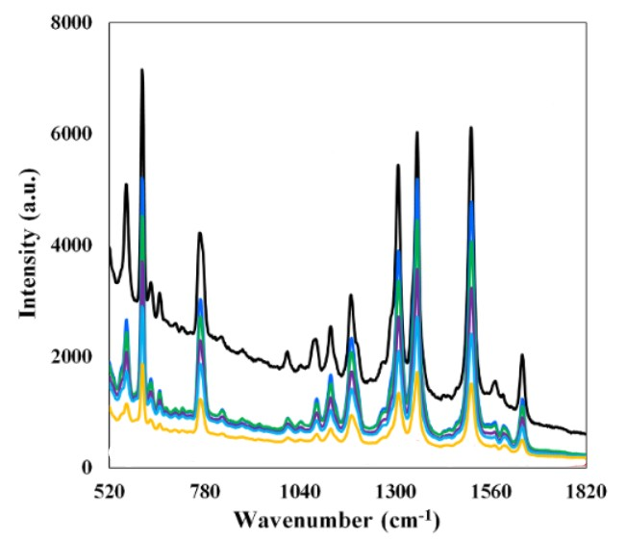

Figure 69: <https://doi.org/10.1016/j.foodchem.2021.129844>

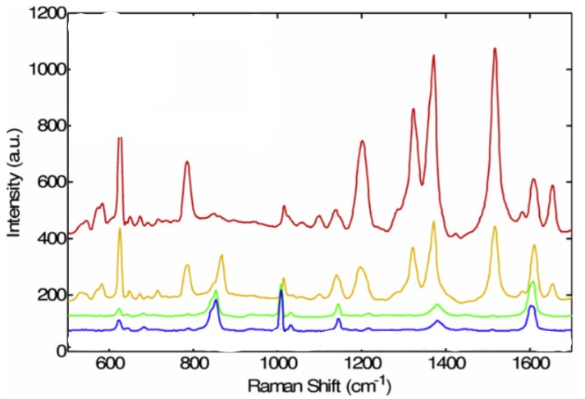

Figure 70: 10.1088/0957-4484/21/41/415301

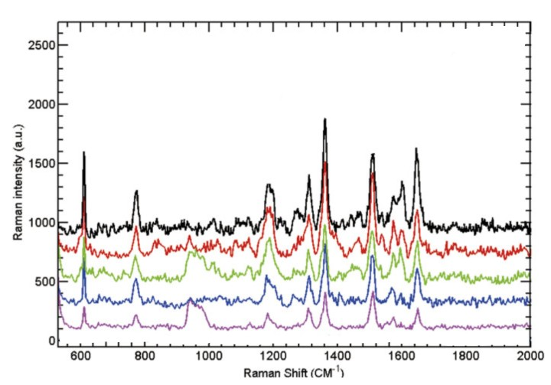

Figure 71:: <https://doi.org/10.1557/jmr.2013.352>

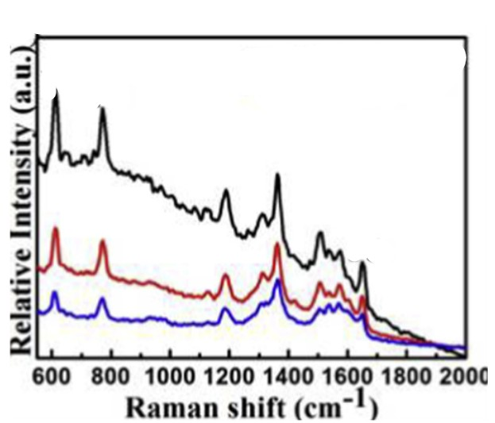

Figure 72:: <https://doi.org/10.1016/j.carbon.2013.06.027>

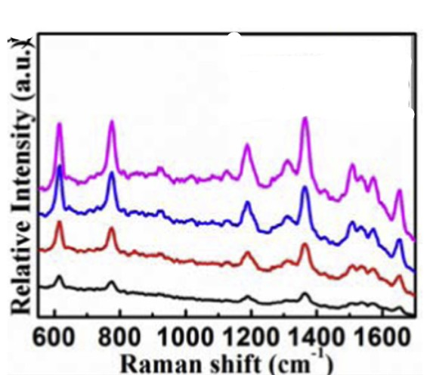

Figure 73:: <https://doi.org/10.1016/j.carbon.2013.06.027>

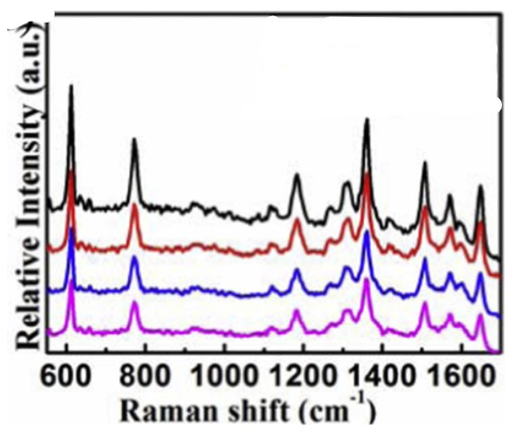

Figure 74:: <https://doi.org/10.1016/j.carbon.2013.06.027>

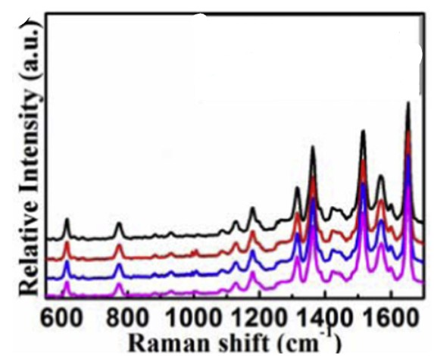

Figure 75:: <https://doi.org/10.1016/j.carbon.2013.06.027>

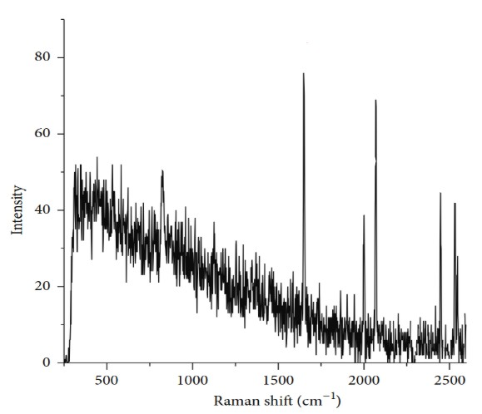

Figure 76:: <https://doi.org/10.1155/2015/895317>

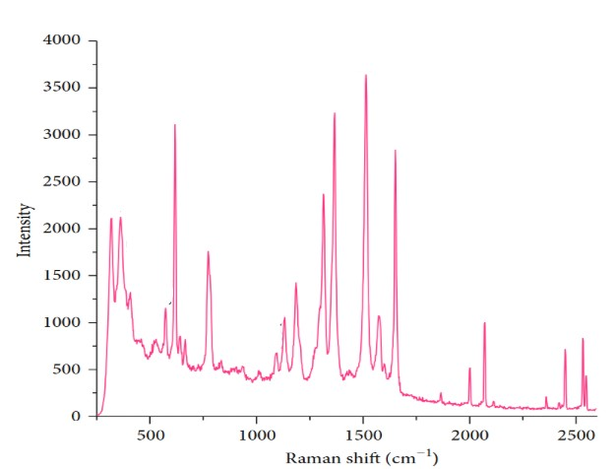

Figure 77:: <https://doi.org/10.1155/2015/895317>

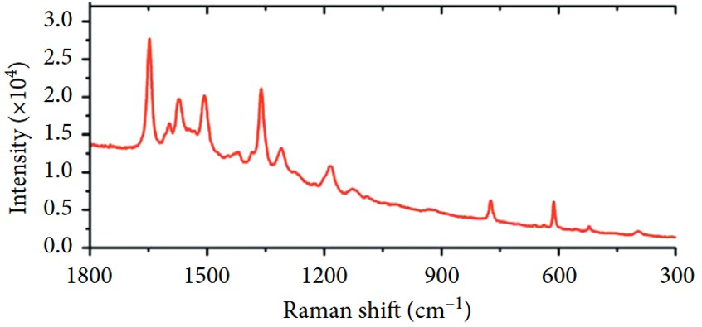

Figure 78:: https://doi.org/10.1155/2018/8050524

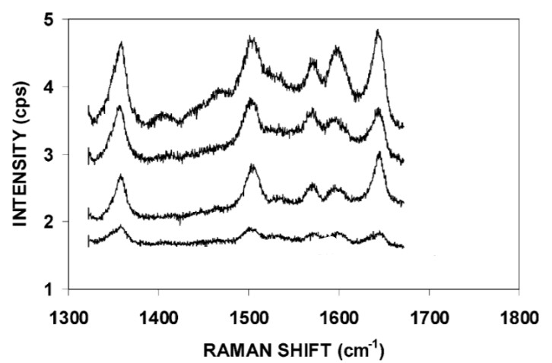

Figure 79:: <https://doi.org/10.1016/S0009-2614(03)00737-1>

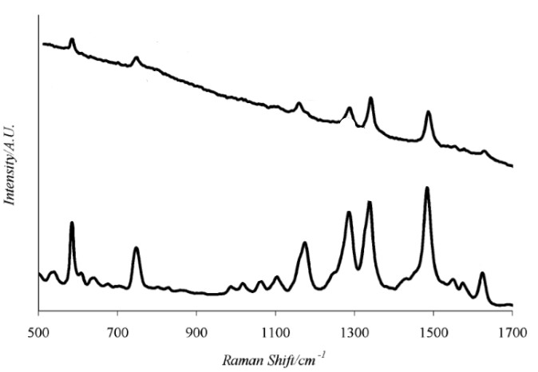

Figure 80:: <https://doi.org/10.1021/jp048430p>

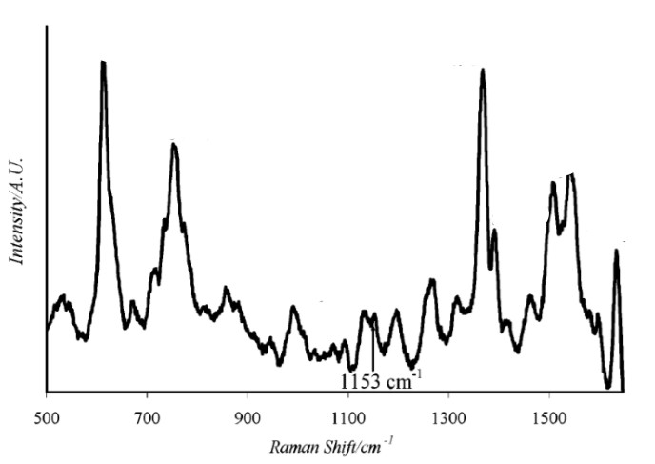

Figure 81:: <https://doi.org/10.1021/jp048430p>

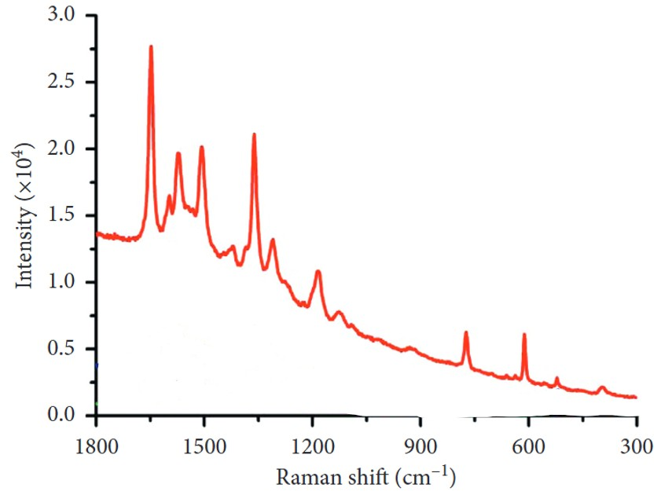

Figure 82::  [**https://doi.org/10.1155/2018/8050524**](https://doi.org/10.1155/2018/8050524)

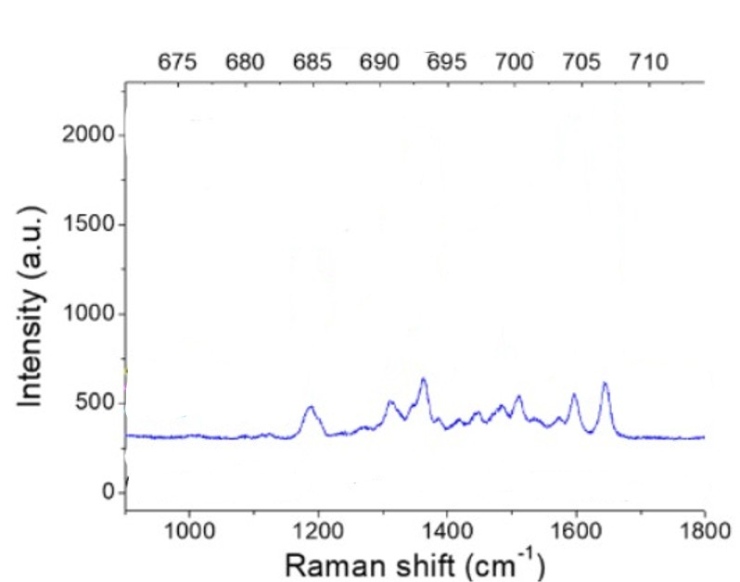

Figure 83:: [**https://doi.org/10.3390/s17112563**](https://doi.org/10.3390/s17112563)

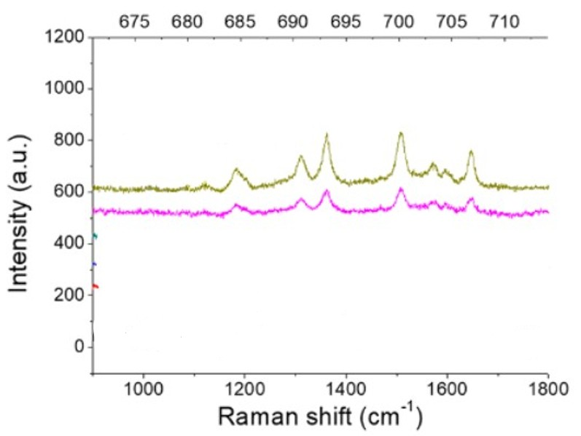

Figure 84:: [**https://doi.org/10.3390/s17112563**](https://doi.org/10.3390/s17112563)

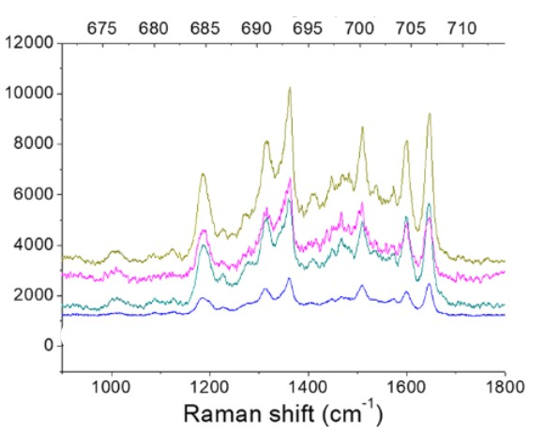

Figure 85:: [**https://doi.org/10.3390/s17112563**](https://doi.org/10.3390/s17112563)

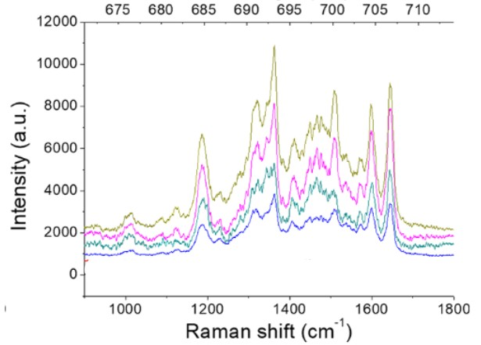

Figure 86:: [**https://doi.org/10.3390/s17112563**](https://doi.org/10.3390/s17112563)

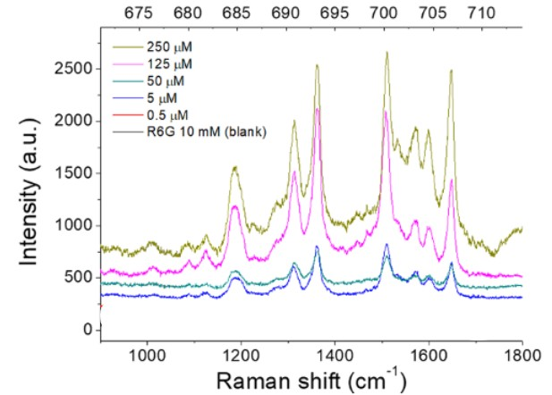

Figure 87:: [**https://doi.org/10.3390/s17112563**](https://doi.org/10.3390/s17112563)

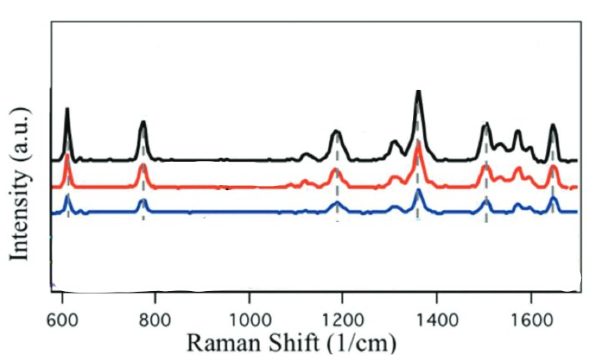

Figure 88:: <https://doi.org/10.1002/adom.201801249>

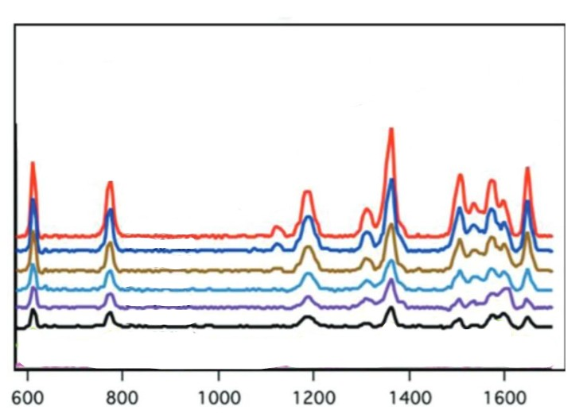

Figure 89:: <https://doi.org/10.1002/adom.201801249>

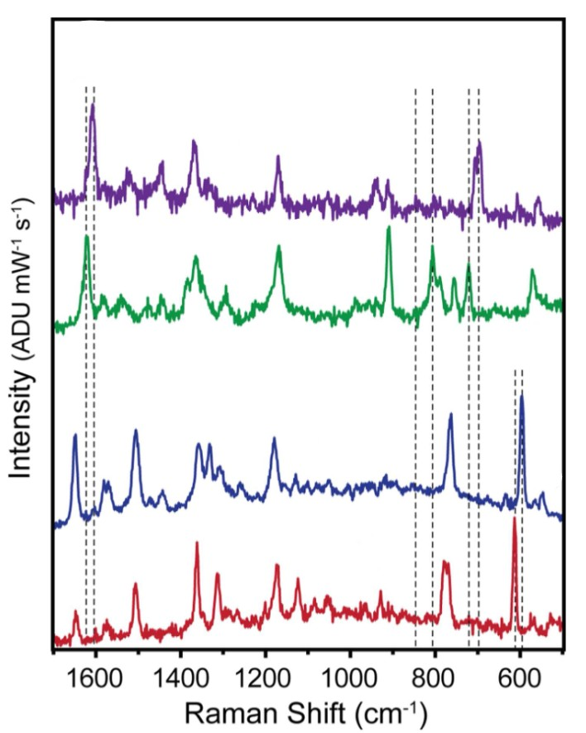

Figure 90::<https://doi.org/10.1021/acs.jpcc.6b00606>

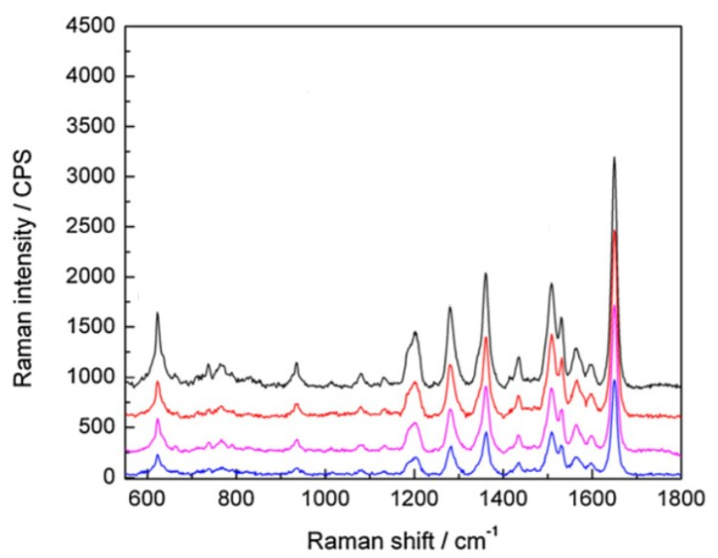

Figure 91::10.1088/0960-1317/22/12/125007

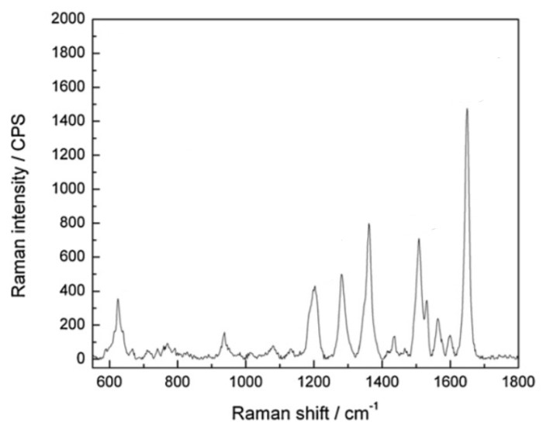

Figure 92::10.1088/0960-1317/22/12/125007

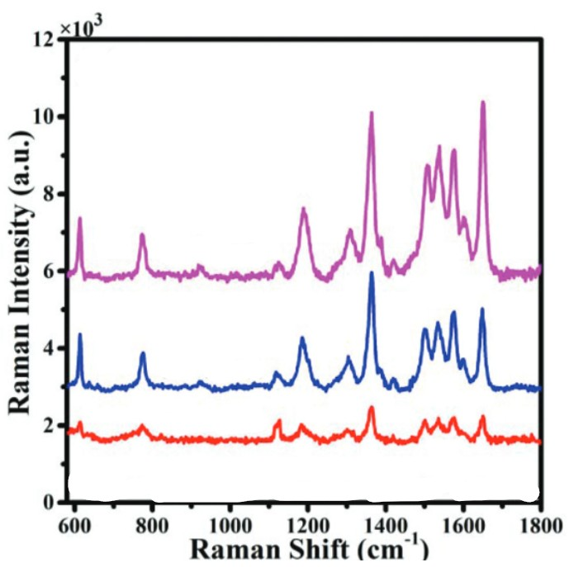

Figure 93::10.1039/c9nr07098b

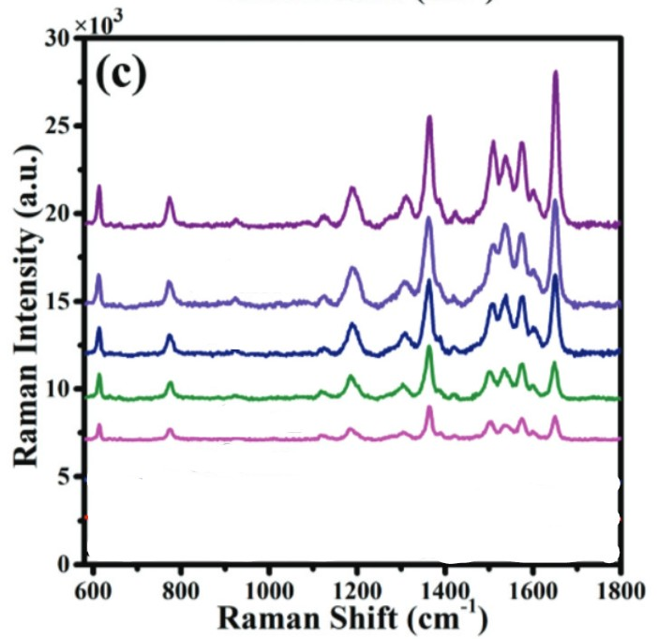

Figure 94::10.1039/c9nr07098b

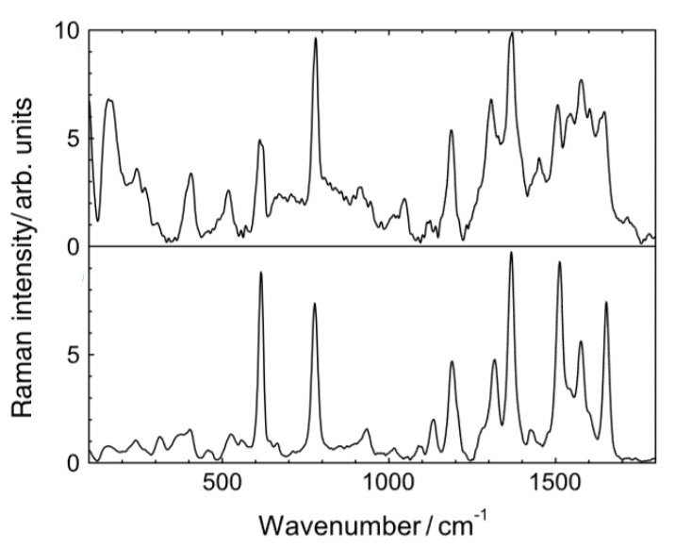

Figure 95 : 10.1002/jrs.1496

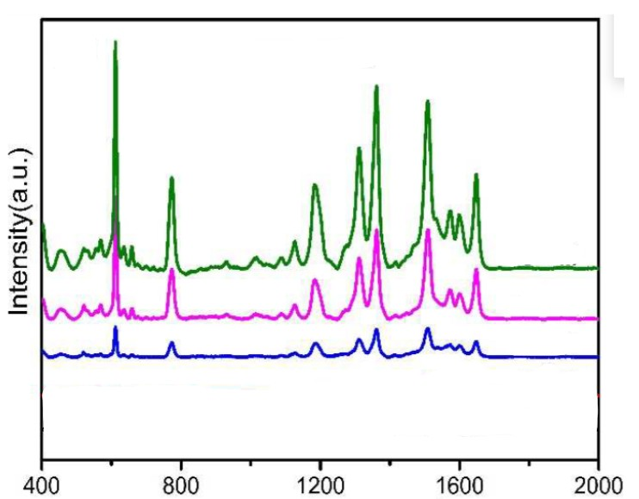

Figure 96 : <https://doi.org/10.1016/j.talanta.2019.120631>

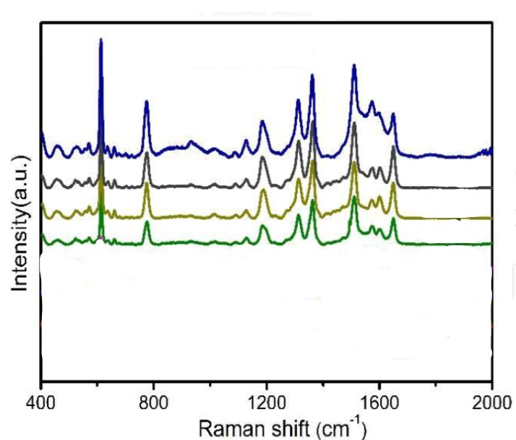

Figure 97 : <https://doi.org/10.1016/j.talanta.2019.120631>

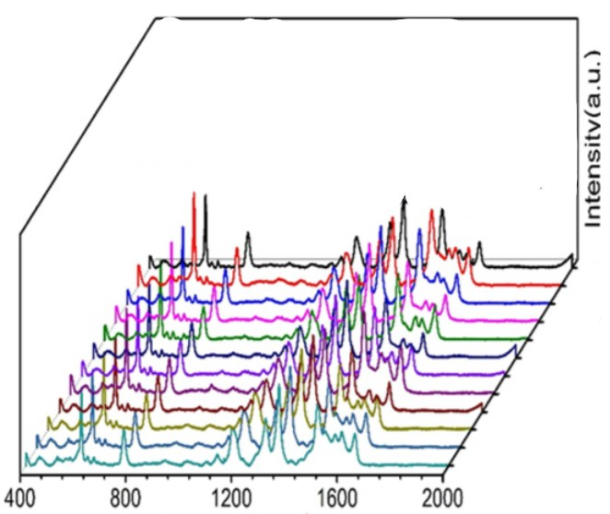

Figure 98 : <https://doi.org/10.1016/j.talanta.2019.120631>

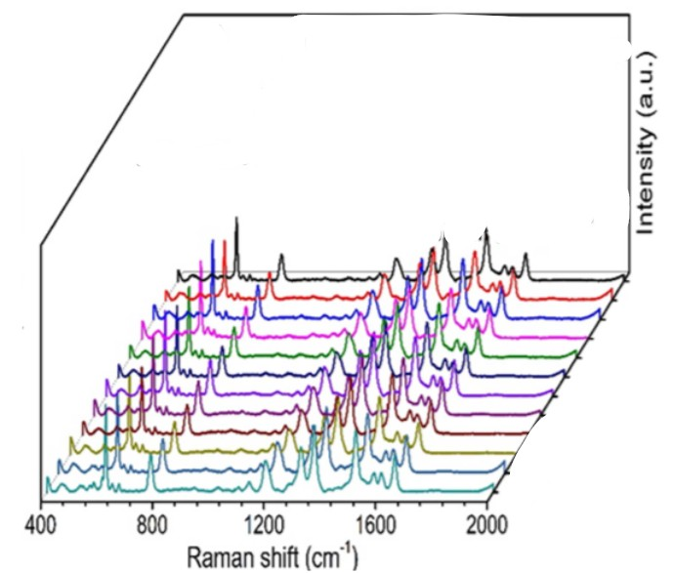

Figure 99 : <https://doi.org/10.1016/j.talanta.2019.120631>

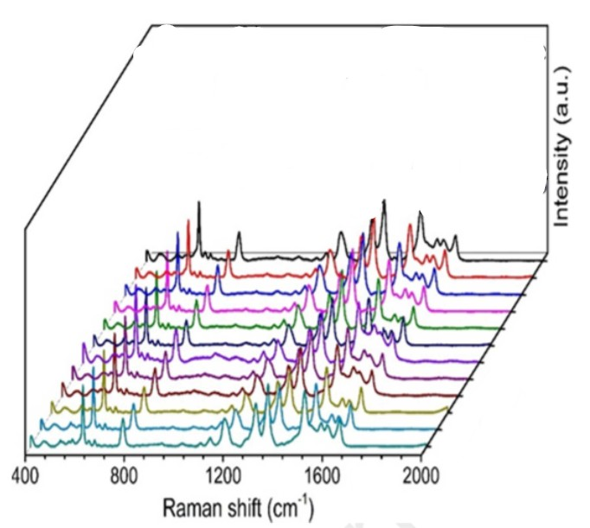

Figure 100 : <https://doi.org/10.1016/j.talanta.2019.120631>

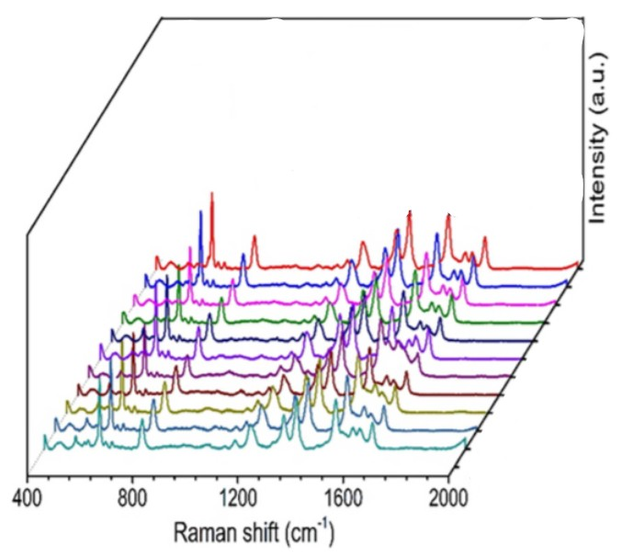

Figure 101 : <https://doi.org/10.1016/j.talanta.2019.120631>